Hi Sunny –

Thank you for making the revisions… its looking great overall! I had a few other adjustments I’m hoping to have made… I will do my best to describe them below:

1 – Removal of Short Ratio

Let’s just not plot this value at all. It can be removed. I had something in mind for it but I think its just cluttering the chart. The result will be just two axes on the chart instead of the current three.

2 – Making the grid lines optional

Is it possible to make the grid lines optional and disabled by default? Ideally, having an additional button in the legend or under the graph that will activate them for the user when clicked.

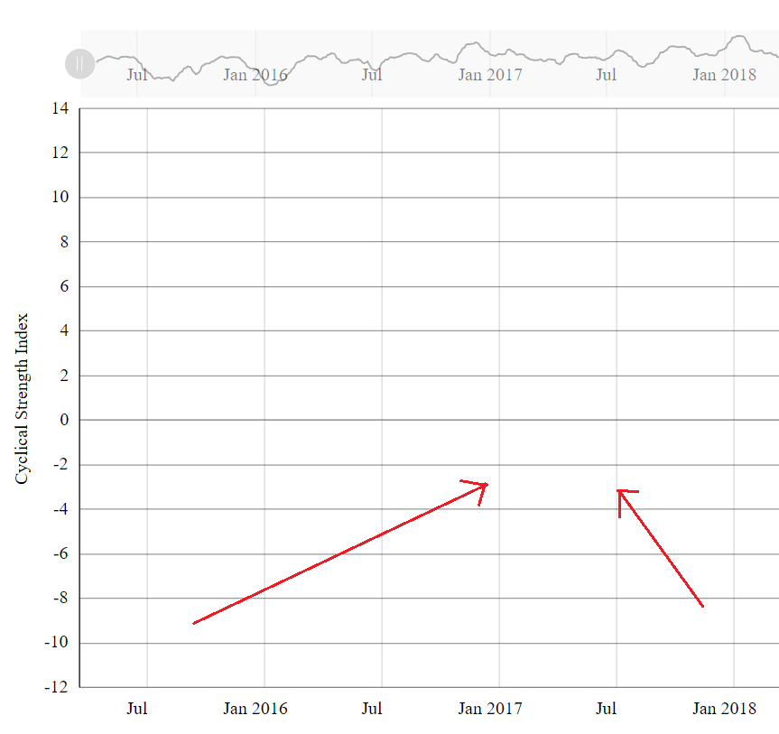

3 – Increasing boldness of CSI lines and 0 line

Is it possible to make the CSI lines a bit more bold? And also, the zero line if possible? I think this will make them a easier to see. I took a quick screenshot of the boldness on the current chart which I think would be good to shoot for:

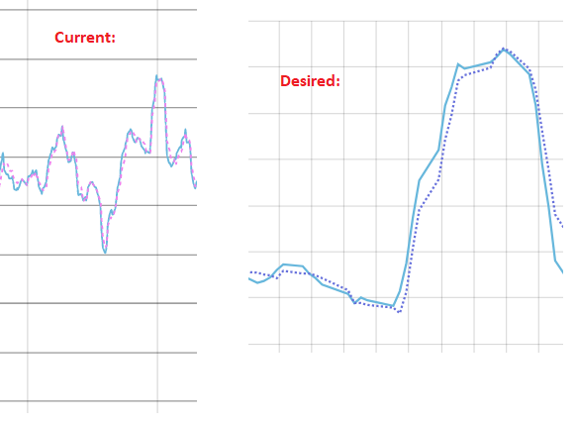

Chart #3

I would like to make a bar chart with two bars… one bar showing all time returns of SPY and the second showing individual returns for each of the four CSI quadrants. I have included a dataframe CSV for us to experiment with. A screenshot of the dataframe is below:

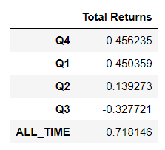

What I would like this bar chart to “show” is that by investing in SPY during quadrants 1, 2 and 4 only (and omitting quadrant 3), you can outperform the market.

There is an approximate bar chart from amcharts that I’m hoping will yield the desire output. It can be found here:

<https://www.amcharts.com/demos/stacked-column-chart/>

I’ve included a quick screenshot of it below with some annotations that I made on it:

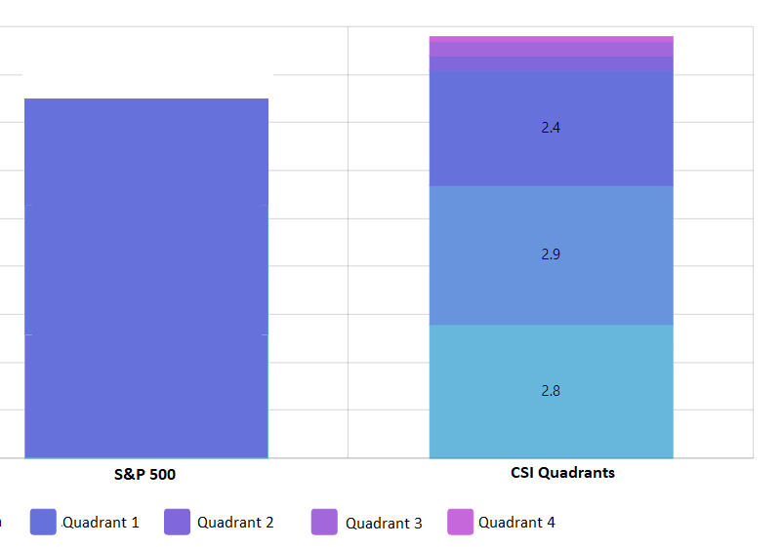

Here’s the tricky part though… as you can see in the dataframe, Q3 has negative cumulative returns. So I’m not sure what will happen if we try to graph a negative number. My \*hope\* is that when all four quadrants are being plotted, that both the S&P500 bar and the CSI quadrants bar will be the same height. My other hope is that when Q3 is disabled by clicking it in the legend, that the effect will be the CSI quadrant bar will be taller than the S&P500 bar. That’s my hope at least and I think it will demonstrate what it is I’m trying to show… which is that by only investing during quadrants 1 and 4 (and maybe 2 as well), you will outperform the market.